SIMATS ENGINEERING (SAVEETHA SCHOOL OF ENGINEERING)
Department of Artificial Intelligence and Data Science

ASSESSMENT TOOL 1 – Experiments

Course Code: | DSA03 | Course Title: | Natural Language Processing
CO Assessed: | CO3 – Precision | Assessment: | Assessment Tool 1 – Experiments
Weightage: | 50% of CIA
CO5 Statement: | Apply N-gram models, smoothing techniques, part-of-speech tagging systems and to evaluate effective syntactic analysis. (BL-3)
Student Name: | R.Mouni | Reg. No.: | 192472283
Section / Batch: | CSE-AI-3rd yr | Date: | 8/8/26

Code of Conduct
I _____________R.Mouni 192472283_____________ (Name / Reg No) certify that this submission is my original work and that I have adhered to the guidelines specified for this assessment. I understand that any violation of academic integrity rules will result in disciplinary action.
Signature of the Student: _______R.Mouni__________________
Instructions
- Perform all experiments using Google Colab.
- Create a separate notebook (.ipynb) for the assessment.
- Ensure all code is executable without errors.
- Include appropriate comments explaining the logic used.
- Complete all three experiments in a single Google Colab notebook.
- Execute all cells and display the outputs for the given test cases.
- Save the notebook with the naming convention: RegNo_Name_CO3-AT1.ipynb
- Upload the notebook to your GitHub repository.
- Ensure the repository is public or accessible to the instructor.
- Submit the following:
- GitHub Repository Link in GCR
- Google Colab Share Link in GCR
- Screenshots of uploaded coding and output files as printout.
- Duration: 30 minutes.
Section / Topic | Focus | Experiment Questions
Context-Free Grammars for English  Syntax, Context-Free Rules and  Trees, Sentence-Level Constructions,  Parsing, Top-Down Parsing, Earley Parsing | Design a Python program to validate sentences using CFG production rules and construct parse tree representations for valid sentences. | Q1
Agreement, Feature Structures, Sub Categorization | Design a Python program to verify subject–verb agreement and validate grammatical constraints using feature structures and subcategorization rules. | Q2
Probabilistic Context-Free Grammars (PCFGs) | Design a Python program to parse sentences and compute sentence probabilities using probabilistic grammar production rules. | Q3

Annexure A – Experiments

Experiment 1: Context-Free Grammar Rule Validation and Parse Tree Construction Experiment Description
def parse_cfg(sentence):
words = sentence.split()
# Sentence must have exactly 5 words
if len(words) != 5:
return "Invalid Sentence"
det = ["the", "a"]
noun = ["student", "teacher", "book"]
verb = ["reads", "likes"]
# Grammar:
# S → NP VP
# NP → Det N
# VP → V NP
if (words[0] in det and
words[1] in noun and
words[2] in verb and
words[3] in det and
words[4] in noun):
tree = {
"S": {
"NP": {
"Det": words[0],
"N": words[1]
},
"VP": {
"V": words[2],
"NP": {
"Det": words[3],
"N": words[4]
}
}
}
}
return tree
else:
return "Invalid Sentence"
# Main Program
sentence = input("Enter a sentence: ")
result = parse_cfg(sentence)
print("\nOutput:")
print(result)
Output:
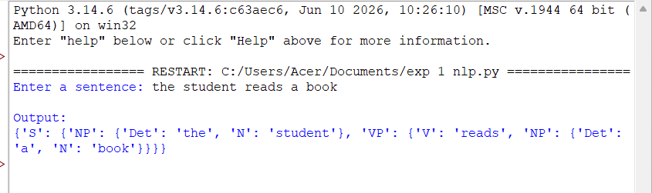

Experiment 2: Agreement and Feature Structure Checking

Experiment Description
def check_agreement(subject, verb):
subjects = {
"he": "singular",
"she": "singular",
"it": "singular",
"they": "plural"
}
verbs = {
"runs": "singular",
"writes": "singular",
"run": "plural",
"write": "plural"
}
if subject not in subjects or verb not in verbs:
return False
return subjects[subject] == verbs[verb]
# Main Program
subject = input("Enter subject: ")
verb = input("Enter verb: ")
print(check_agreement(subject, verb))
Output:
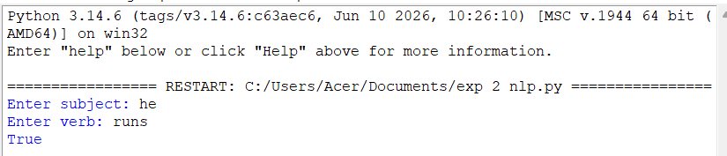

Experiment 3: Probabilistic Context-Free Grammar (PCFG) Parsing
Experiment Description
def sentence_probability(sentence):
words = sentence.split()
if len(words) != 2:
return 0.00
np = {
"John": 0.6,
"Mary": 0.4
}

vp = {
"runs": 0.5,
"walks": 0.5
}
if words[0] in np and words[1] in vp:
probability = 1.0 * np[words[0]] * vp[words[1]]
return round(probability, 2)
return 0.00
# Main Program
sentence = input("Enter sentence: ")
print("Probability =", sentence_probability(sentence))
Output:
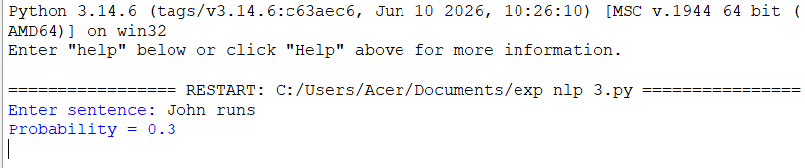

Rubrics for Calculation
Criteria |  | Weightage | Level 4 – Exemplary |  |  |  | Level 3 – Proficient |  |  | Level 2 –  Developing |  |  | Level 1 –  Beginning
Understanding of Concepts |  | 25 | Demonstrates thorough understanding and  effectively integrates multiple concepts/technologies |  |  |  | Good understanding with proper  integration of most concepts |  |  | Basic understanding;  limited or partial integration |  |  | Poor understanding; unable to integrate concepts
Experimental Design |  | 30 | Well-planned, systematic implementation with optimal solution |  |  |  | Correct implementation with minor issues |  |  | Basic implementation  with errors or inefficiencies |  |  | Incorrect or incomplete implementation
Use of Tools |  | 20 | Effective and advanced use of tools/technologies with proper configuration |  |  |  | Appropriate use of tools with correct execution |  |  | Limited or inconsistent use of tools |  |  | Incorrect or minimal use of tools
Analysis of Results |  | 15 | Insightful analysis with accurate interpretation and validation of results |  |  |  | Good analysis with reasonable  interpretation |  |  | Basic analysis with limited insights |  |  | Poor or incorrect  analysis of results
Documentation |  | 10 | Clear, well-structured documentation with  diagrams, code, and  results |  |  |  | Organized documentation  with necessary details |  |  | Basic documentation  with missing details |  |  | Poor or incomplete documentation
Q. No.  /  Criteri a Level | Understandin g of Concepts |  |  | Experimenta l Design |  | Use of Tools |  | Analysis of  Results | Documen  tation |  |  | Sub. Total |  | Tota l %
1
2
3
Faculty In-charge |  |  |  |  | Course Coordinator |  |  |  |  |  | Program Director
Signature: _______________ |  |  |  |  | Signature: _______________ |  |  |  |  |  | Signature: _______________
Date: ___________________ |  |  |  |  | Date: ___________________ |  |  |  |  |  | Date: ___________________

